26.87: a) 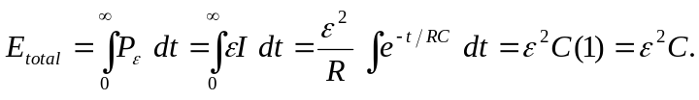
b) 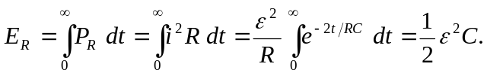
c) 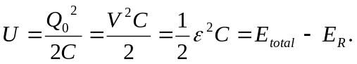
d) One half of the energy is stored in the capacitor, regardless of the sizes of the resistor.

